**Project Design Phase**

**Problem – Solution Fit Template**

|  |  |
| --- | --- |
| Date | 17 February 2026 |
| Team ID | LTVIP2026TMIDS67078 |
| Project Name | Calculating Family Expenses using ServiceNow |
| Maximum Marks | 2 Marks |

**Problem – Solution Fit Template:**

The Problem-Solution Fit simply means that you have found a problem with your customer and that the solution you have realized for it actually solves the customer’s problem. It helps entrepreneurs, marketers and corporate innovators identify behavioral patterns and recognize what would work and why

**Purpose:**

* Solve complex problems in a way that fits the state of your customers.
* Succeed faster and increase your solution adoption by tapping into existing mediums and channels of behavior.
* Sharpen your communication and marketing strategy with the right triggers and messaging.
* Increase touch-points with your company by finding the right problem-behavior fit and building trust by solving frequent annoyances, or urgent or costly problems.
* **Understand the existing situation in order to improve it for your target group.**

**Template:**

References:

1. <https://www.ideahackers.network/problem-solution-fit-canvas/>
2. <https://medium.com/@epicantus/problem-solution-fit-canvas-aa3dd59cb4fe>

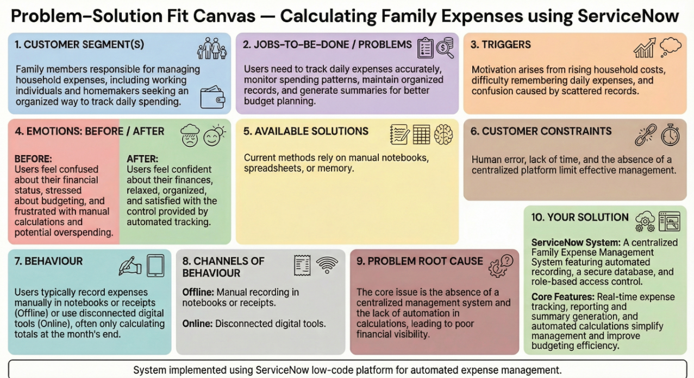**Customer Segment**

Family members responsible for managing household expenses, including working individuals and homemakers who need a simple way to track daily spending.

**Problem**

Many families face difficulties in tracking and managing their daily expenses due to:

* Manual recording of expenses in notebooks or scattered sources
* Lack of centralized system to store and monitor financial data
* Difficulty calculating total expenses and spending patterns
* No automated reporting or real-time visibility of expenses
* Time-consuming and error-prone calculations

These challenges lead to poor financial planning and lack of control over household budgets.

**Existing Alternatives**

Currently, users manage expenses using:

* Manual notebooks or spreadsheets
* Basic calculator applications
* Memory-based tracking
* Multiple disconnected tools

These methods are inefficient, inaccurate, and lack automation.

**Solution**

The proposed solution is a **Family Expense Calculation System developed using ServiceNow**, which provides:

* Centralized expense recording system
* Automated calculation of total expenses
* Daily expense tracking with categorization
* Real-time data updates using business rules
* Expense summaries and reporting capabilities
* Secure and role-based access control

The system simplifies expense management and improves financial visibility for families.

**Value Proposition**

The solution delivers the following benefits:

* Saves time by automating calculations
* Reduces human errors in expense tracking
* Provides clear financial insights and reports
* Improves budget planning and decision-making
* Enables centralized and secure data storage
* Enhances user experience through an easy interface

**Customer Benefits**

* Better control over household finances
* Improved financial awareness
* Reduced stress related to money management
* Faster access to expense information
* More accurate budgeting and planning